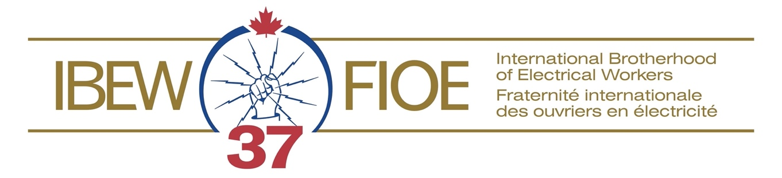
Contract Proposals - Nuclear

- We will soon start contract negotiations for your collective agreement.

- We want your input. Please tell us about issues in the workplace that affect you.

- Submit a new form for each issue.

Briefly describe the issue:

What concerns you about this issue; why is it important to you?

What are some ways that it could be resolved?

Please give us your name, classification and contact information in case we need to do some follow-up with you: Your input is for the negotiating team’s use only – your name will not be shared with the company or the general membership.

Name: Classification:

Workplace Location: Bargaining Unit: ____________________________

Telephone:
E-Mail:

Thank you for your help! Your input will help guide the negotiating team.
There are several ways to send completed contract proposal forms to the IBEW office:
· Email: negotiations@ibew37.com
· NB Power internal mail: addressed to “IBEW Local 37, 138 Neill St., Fredericton”; or
· Toll free fax: 1-800-723-1226.

